Janani Seneviratne

CMSC 203 Preliminary Summer Course Work

Practice Section 1

**Part 1 – Github Repository**

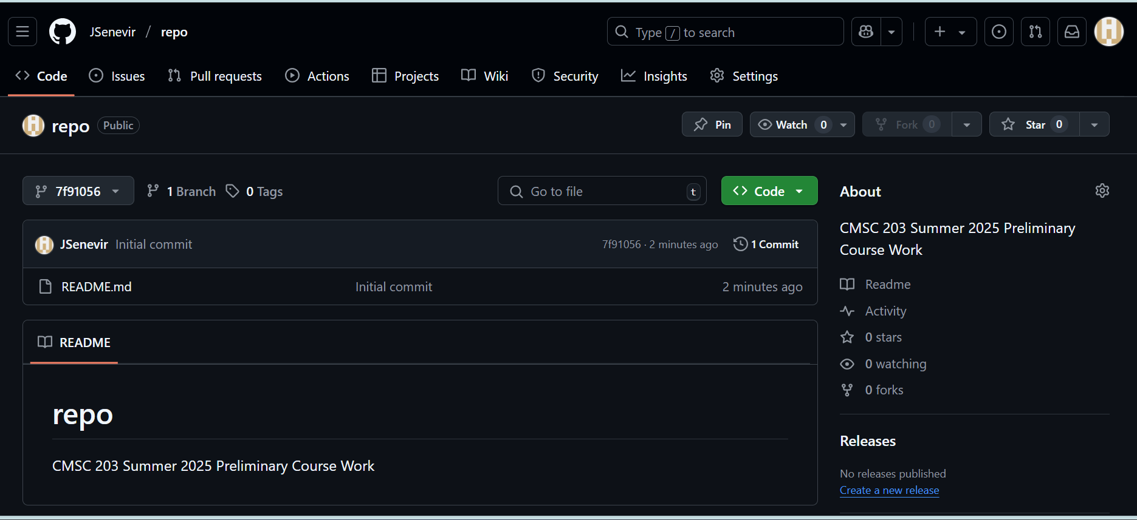

**Part 2 – JDK Installation and Run**

*Step 1: javac command line prompt*

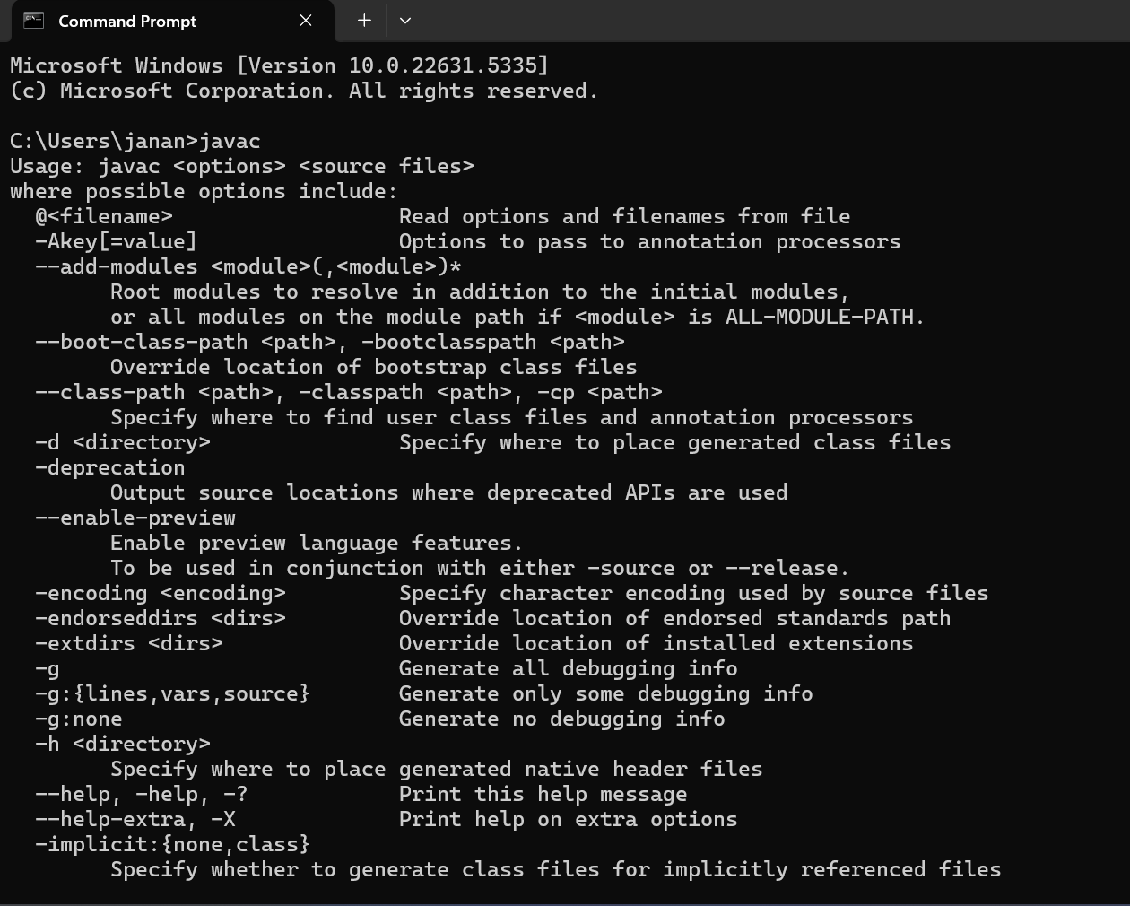

*Step 2: Compile HelloWorldApp.java & Run HelloWorldApp.class*

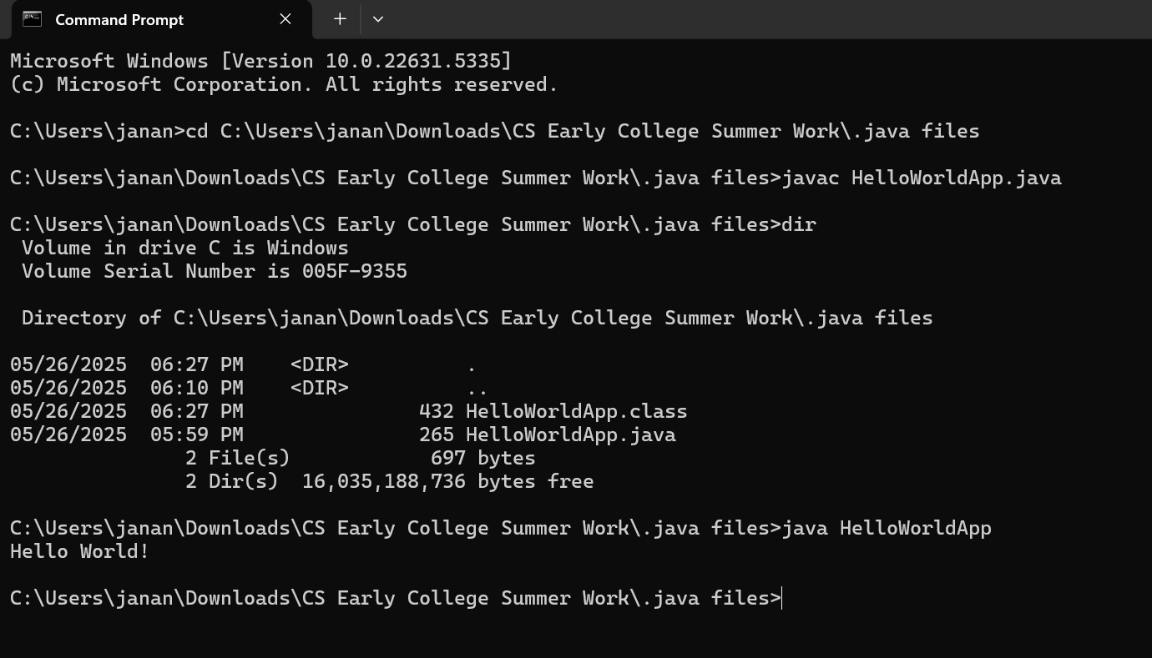

**Part 3 – Eclipse Installation and Testing**

*Step 1*

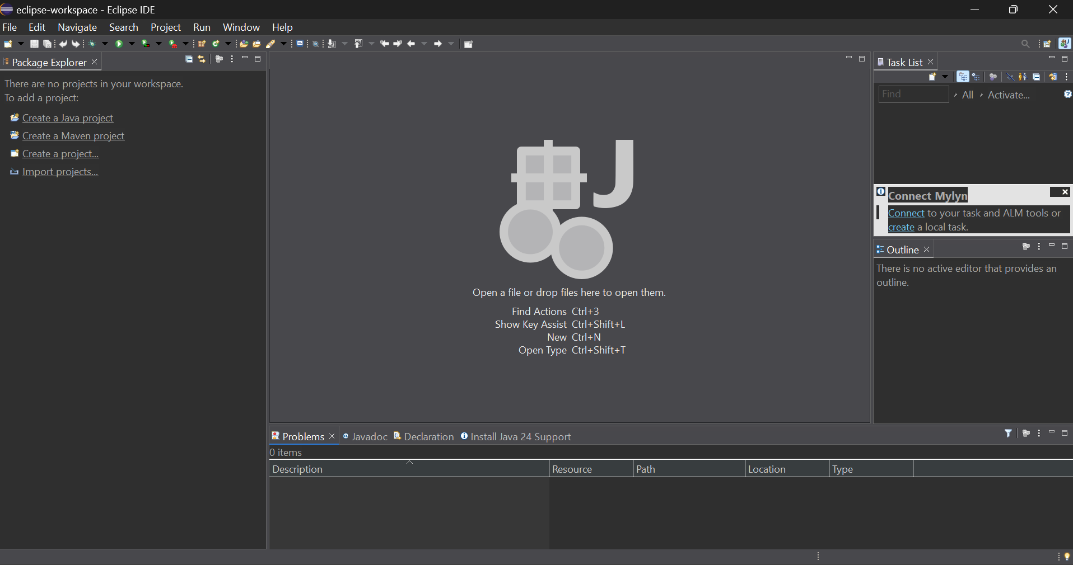

*Step 2*

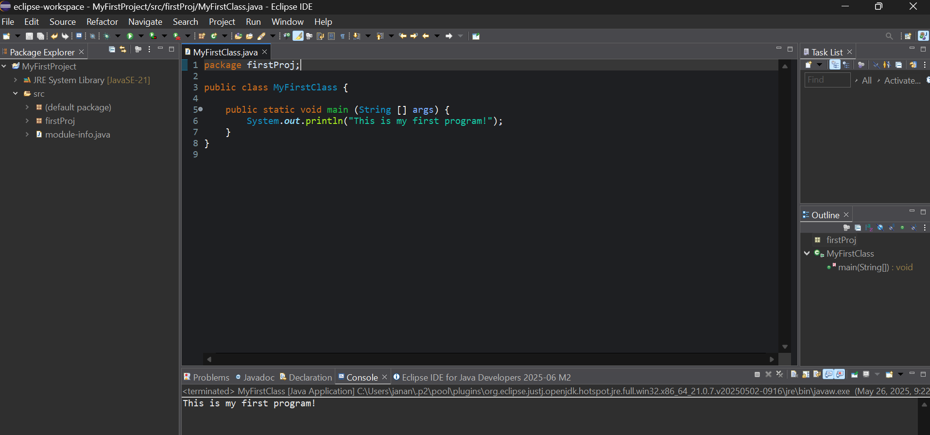

**Part 4: Eclipse Practice Exercises**

*“StudyPage” example w/ my own comments*

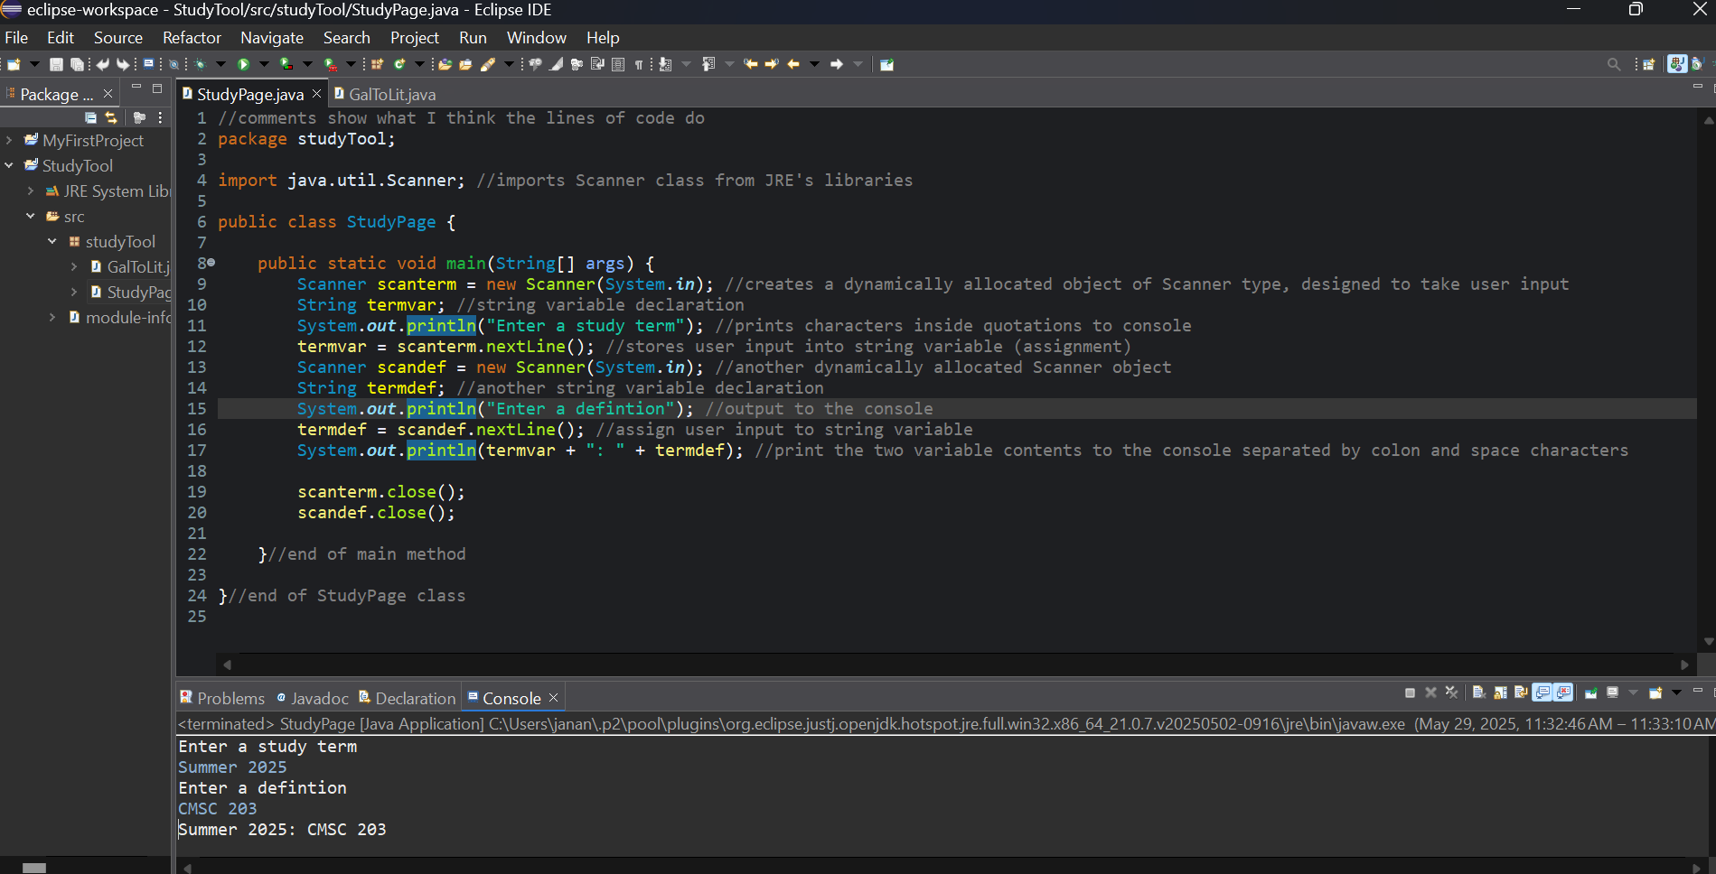

*Gallons to Liters conversion activity*

